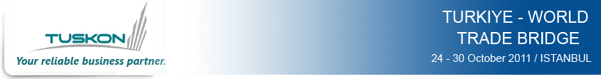
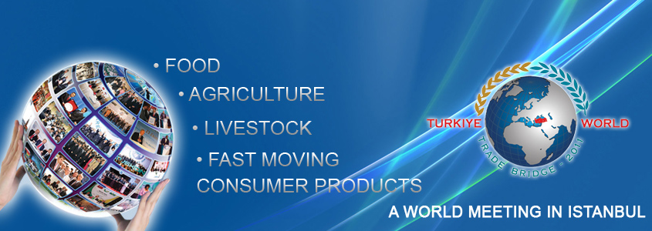

About Program
Food-Agriculture-Fast Moving Consumer Goods-Home Appliances
The Confederation of Businessmen and Industrialists of Turkiye (TUSKON) is organizing a new track of its world famous series of international business summit, Turkiye World Trade Bridge, on October 24-30, 2011 in Istanbul.
Having been organized since 2006, TUSKON’s World Trade Bridge series has gained a wide recognition in international business circles. Turkiye World Trade Bridge 2011 (TWTB 2011) is likely to be a prominent one as it has a sectoral focus for the first time in the history of World Trade Bridges.
TWTB 2011 continue to possess the most basic characteristics such as product exhibition, scheduled B2B meetings, historical and cultural activities, factory and company visits and complimentary trips to different parts of Turkiye.
There are three main differences in TWTB 2011 compared to previous programs
1. The event is only targeting food, agriculture and fast moving consumer products segments
2. Total number of international participants (companies) is limited to 700.
3. The event is taking place in Istanbul Congress Center.
Main Sectors | Subsectors and Product Groups
Food | - All kinds of food and beverages  - processed food  - raw materials used in food manufacturing  - food packaging products  - food manufacturing and packaging machinery
Agriculture, Livestock and Poultry | - All kinds of agro products (beans, grains, oil seeds etc.)  - Livestock and poultry products (cattle and chicken meat, milk products, sea food etc.)  - Agricultural machinery, equipments and Technologies (irrigation systems, agro machinery etc.)  - Agricultural raw materials (animal feed, fertilizers etc.)
Fast Moving Consumer Products  (FMCG) | - Cosmetics  - Personal hygiene products (razor, toothpaste and toothbrush, toilet paper, napkin, tampons, pads etc)  - Cleaning products (detergents, liquid soap, shampoo, softener etc.)  - Kitchenware (steel pans, plastics pot and bowls etc.)  - Small home appliances (mixers, blenders, fruit extractors, kettle and etc
Targeted Sectors and Industries

Who ShouldParticipate ?
Buyers, resellers, importers, catering companies and distributors in the fields of food products, agriculture and livestock products, fast moving consumer products and companies dealing with all kinds of machinery in these fields
Why Should I Participate?
- TWTB 2011 is a highly professional international business summit. It is open only to registered companies selected among thousands of applicants from Turkiye and the world, selected among thousands of applicants.
- You can participate in day long B2B meetings with Turkish companies. All B2B meetings are scheduled beforehand.
- The event is organized by TUSKON which is the largest and most widespread Turkish business NGO with 34.000 member businesspeople and more than 100.000 companies.
- Leading 150 Turkish manufacturers will participate with their product display booths. 1000 distinguished Turkish companies will participate in B2B meetings.
- TWTB 2011 is targeting specific sectors and product groups making the event even more promising for international companies.
- You will have the chance to meet with superior quality products at more reasonable prices
- You will experience the level of industrial development of Turkiye which is one of the most dynamic and the fastest growing economies of the world.
- TWTB 2011 is a platform where you can meet with reliable Turkish manufacturers, investors and traders.
- TWTB 2011 is totally free for international applicants.
Turkiye World Trade Bridge 2011 Profile
Participating Countries | 150
Participating International Businesspeople
  Total | 715
  Africa | 350
  Asia / Pacific | 146
  Eurasia | 83
  Europe | No Limit
  Latin America | 56
  North America | 30
  Middle East | 50
Participating Turkish Businesspeople | 1000
Turkish Exhibitors | 400
B2B Meetings | 25.000

Tentative Program
Days | Explanation
October 23-24, 2011  Sunday and Monday | - Arrival in Istanbul  - Check into Hotels
October 25, 2011  Tuesday | - Historical and Touristic City Tour in Istanbul
October 26, 2011  Wednesday | - Opening Ceremony of Turkiye World Trade Bridge 2011  - Visiting Product Display Booths of Turkish Exhibitors  - Special B2B Meetings with Turkish Exhibitors  - Gala Dinner of Turkiye World Trade Bridge 2011
October 27, 2011  Thursday | - B2B Meetings with 1000 Turkish Companies  - Visiting Product Display Booths of Turkish Exhibitors
October 28-30, 2011  Friday, Saturday and Sunday | - Visits to Anatolian Cities  - Departure from Istanbul to Selected Cities in Other Parts of Turkiye  - Factory, Company and Industrial Zone Visits  - Local Business Matchmaking with Turkish Companies  - Historical, Cultural and Touristic Tours

Frequently Asked Questions?
1. Who is eligible for TWTB 2011?
TWTB 2011 is open only to importer companies. An applicant should have an interest to import from Turkiye at least in one product group among target industries.
2. What if my company has some operations in sectors other than the target sectors and industries? Will I be able to make B2B meetings in these additional sectors as well?
If your company has an interest or operation in other fields of business in addition to your operations in any of targeted sectors, food, agriculture and fast moving consumer products, then TUSKON will find you new counterparts in these additional fields as well.
However please keep in mind that your main purpose of participation should still be to meet with Turkish companies in 3 main target industries.
3. What are the costs that I have to cover?
TWTB 2011 is totally free for international participants. There is no entrance fee for you at all. You only need to cover your international airfare and accommodation expenses in Istanbul.
City tours, airport transfers, flights to other cities of Turkiye will be free and offered by TUSKON’s affiliated business associations.
Please keep in mind that the situation is not the same for Turkish participants. Both exhibitors and regular Turkish participants pay a significant amount of application fee. This makes the application process fundamentally selective for Turkish companies.
4. How do you schedule thousands of B2B meetings?
We receive business profiles from international participants until the deadline. Turkish applicants review these profiles and choose online the international companies that they intend to meet. Then TUSKON starts B2B matchmaking process by using special software.
5. I do not speak Turkish. How will I communicate with Turkish businesspeople during B2B meetings?
There is no problem if you do not speak Turkish or a Turkish participant does not speak any foreign language since TUSKON will provide you a separate interpreter who will be able to translate from your own language into Turkish during B2B meetings.
6. What are the mandatory and optional parts of the events?
The main activities on October 26 and 27 are mandatory to participate. Istanbul city tour on October 25 and visits to different Anatolian cities between October 28 and 30, 2011 are optional.
7. What are the recommended latest arrival and earliest departure dates?
You must arrive at Istanbul no later than the evening of October 25, 2011 Wednesday. You also should not leave the event before the close of the event on October 27, 2011 at 18:00.
8. What is the deadline for application?
Application deadline for international participants is October 1, 2011.
9. Whom shall I contact for detailed information or my further questions?
There is a TUSKON representative in your country. If you do not know our representative, please contact us at wtb@tuskon.org for your further inquiries.

