1. Casa Noble

- Careful handpicked selection of blue agave of special quality
- USDA Certified Organic
- Silver or Blanco, Reposado (Aged), Noble Añejo (Extra Aged)
www.casanoble.com

2. Tequila Aeroplano Spirits
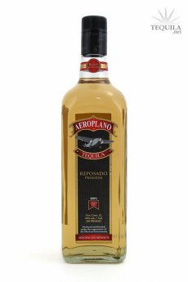
∙ Premium Tequila, with a special process starting with the selection of the best agave, cooking and fermentation of the agave made with the best and highest quality.
- “Reposado”, is aged 3-11 months in white oak barrels
- Silver or “Blanco” is very easy to hold on the tongue, soft and sweet.
- Margarita, ready to serve, made with 100% blue agave and sweetened with agave nectar.
- Aeroplano LX, represents the purity and quality of an ultra-premium tequila.
www.aeroplanotequila.com/

3. Tequila Rojo y Rosa Pasión
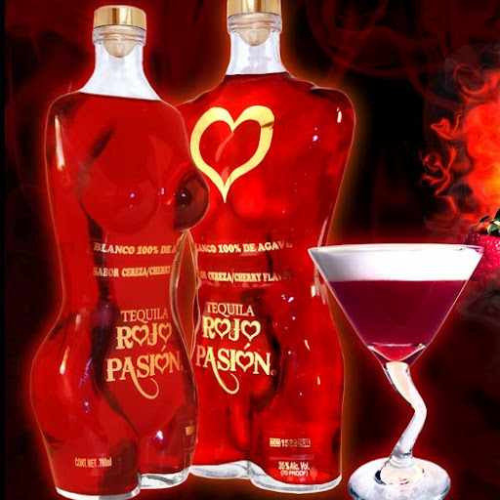
- 100% Agave
- Rosa Pasion Tequila (Pink Passion), pink color with silver plated nuances
- Rojo Pasion (Red Passion) Intense cherry-red color, with purple nuances and fine gold leaves
- Also available fluorescent yellow and bright green.
- Received the 27th International Award for Quality in Food and Beverages in Spain 2011.
www.tequilarojoyrosapasion.com.mx

4. Tequila Scandalo
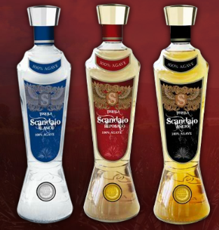
∙ 100% Blue Agave. It is a Perfect Combination of History, Tradition and Technology.
∙ Received Golden Award by the Beverage Testing.
Products: Silver, Aged and Extra Aged.
www.tequilascandalo.com
5. Peninsula Seafood
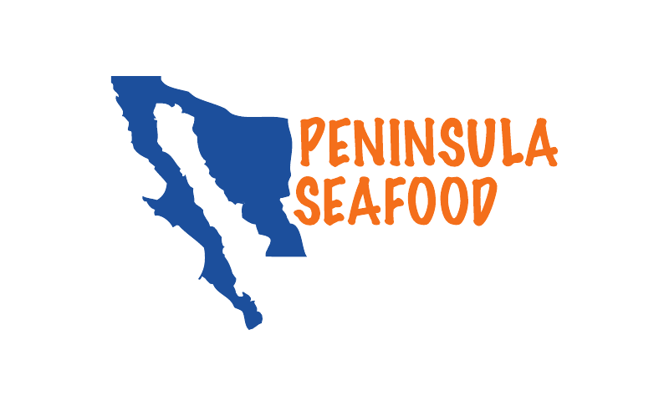
∙ Mexican Shrimp: Litopenaeus Stylirostris, Farfantepenaeus Californiensis, Penaeus Vannamei.
∙ Giant Squid: Dosidicus Gigas
∙ Spiny Lobster: Panulirus Argus
∙ Octopus: Octopus Vulgaris
∙ Scallops: Nodpecten Subnodsus, Argopecten Ventricosus, Pinna Rugosa , Atrina Maura

6. Nopal Export

∙ Nopal has been serving mankind as a food and healing plant for thousands of years.
∙ Nopal has remained a popular food in Mexican cuisine, current research is revealing a rich phytonutrient profile and health benefits.
∙ Ethnobotanical studies of Nopal have guided modern clinical research to confirm activity in the areas of blood sugar management, blood lipid management, inflammation, gastrointestinal disease, oxidative stress and weight management.
∙ Powder and Liquid Presentation.
www.nopalexport.com
7. Café Tostado de Exportación
∙ Company Founded in 1925. The Company owns coffee plantations, wet mills, dry soluble coffee factory and decaffeinated coffee plants.
∙ Certified ISO 9000:2008, USDA Organic, Fair Trade Quality.
∙Variety of packaging: Instant coffee available in sticks, glass jars, cans, standing pouches, bulk
www.catoex.com.mx

8. Natura Extracta
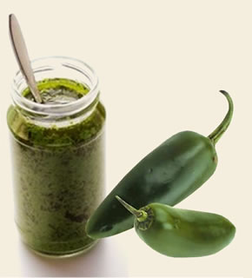
∙Branch of Arancia Industrial, 80+ years serving local industry and abroad.
∙ Oil/Fat Extractives and Water Soluble Extractives.
∙ Produced from several varieties of Mexican chiles: Habanero, Pasilla, Jalapeño, Chipotle, among others.
∙Applications: sauces, seasonings, dressings, snacks, noodles, canned soups, marinades, processed meats, cheeses.
Customers: Flavor house, Spice House, Trader, Blender.
www.naturaextracta.com

9. Botanas La Lupita
∙ Company founded in 1979.
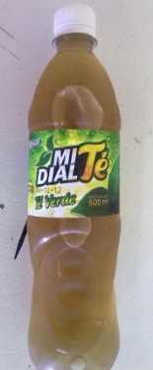
∙ Corn and Wheat Flour Snacks
∙ Manufacture under the most higienic conditions, safety procedures and most typical flavors.
∙Corn flour chips, wheat flour blown out squares, potato chips, nacho chips, corn flour tostada, corn flour tostada with sesame.
www.lalupita.com

10. Mi Dial 3 (Representaciones del Sureste)
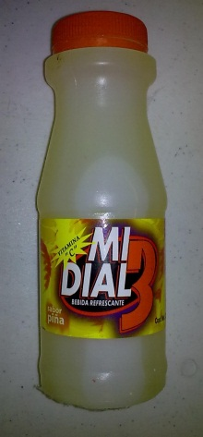
∙ The Company was founded in 2000.
∙ Focused on Flavored Beverages.
∙ Fruit Flavors: Orange, apple, pineapple, grape.
∙ Tea Flavors: Black and Jasmine Tea.
∙ Variety of sizes and presentations, PET Bottles form 235 ml to 3.78 L

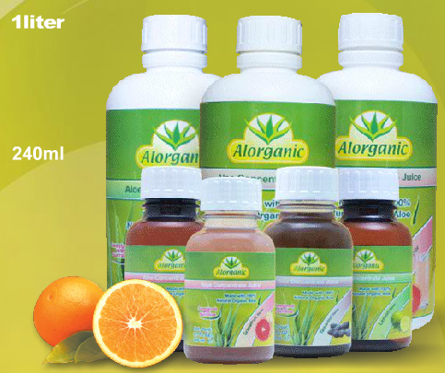
11. SMD
∙ Company with more than 40 years of experience.
∙ Aloe Vera Beverage. 100% organic Aloe Vera eith 100% natural flavors. 1 Lt and 240 ml bottles. Flavors: Lemon, grapefruit, tamarind, apple and strawberry.
∙ Alorganic powder. Due to its high contents of aloe vera,aalow stimulating and fortifying the immune system. Free of conservatives or synthetic flavors, due for all public (kids, pregnant women an diabetics)
- 300 gr pouch. One tablespoon is equivalent for 170ml of Aloe Vera Juice
- Orange or Grapefruit flavors.
www.alorganic.com.mx

