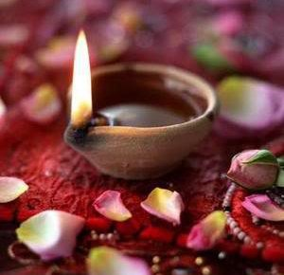

Since 1989

Sumeda
Thai Sumeda (Pvt) Ltd
401/7 Kotte Road,
Pita Kotte,
Sri Jayawardhanapura Kotte
Sri Lanka
Lanka Sumeda Incense Sticks - Agarbhathies - Joss Sticks
Thai Sumeda Ltd. 타이 수메다는 1989년 회사 설립 이후 스리랑카 향 (방향) 의 선두업체로 좋은 평가를 받고 있으며 지역 최고의 제품으로 수상하였습니다.
We are the leading manufacturer’s distributors & exporters of quality hand rolled, hand dipped incense sticks, incense powder & incense products in Sri Lanka since year 1989.We proudly inform you that, we won BEST LOCAL PRODUCT award from the Industrial Development Bored in Sri Lanka.

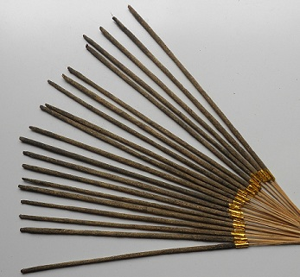
스리랑카의 쇼핑센터 대형마트, 관광지, 아울렛 등에 납품하고 있으며 유럽지역에 수출하고 있습니다
100% 자연제품으로 각종 허브를 이용하여 만든 제품입니다.
웹사이트를 참고해주세요

We supply our quality products to all the Leading Super Markets, Leading shopping Centers as well as many Tourists out lets. Currently we do export to Europe. Our products are quality controlled and non toxic. We give you best low price for the wholesale Market.
Also We have 100% natural incense sticks made out from rare herbs and ayurwedic herbs, mixed with Frank Incense and other valuable roots herbs.
Our web site is under construction and temporally you can visit our face book page
https://www.facebook.com/pages/LANKA-SUMEDA-INCENSE-STICKS/186400894265
Please feel free to contact us and get touch with us for long term good business relationship.

Each Packet Contains 20 - 9” thick Incense Sticks
9인치, 각 20개
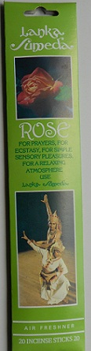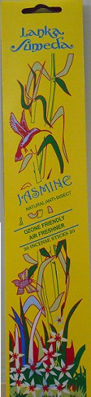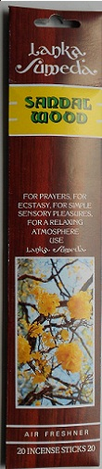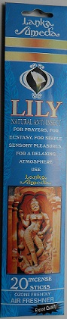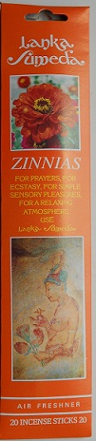

각 한 박스에 US $ 0.5
12박스에 US $ 6.00

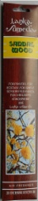 Sandal Wood Incense Sticks, 20 Sticks in a Pack US $0.50 (Each Pack)
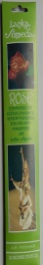Rose =========do========= US $0.50 (==do==)
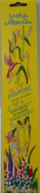Jasmine =========do========= US $0.50 (==do==)
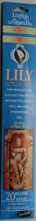Lily =========do========= US $0.50 (==do==)
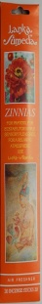Zinnias ========= do========= US $0.50 (==do==)

$6.00 for 1 Dozen
Sandal Wood, Rose, Jasmine, Lilly, Zinnias 가 가장 인기 있는 제품입니다.

Sandal Wood, Rose, Jasmine, Lilly, Zinnias
This five variety of fragranced incense sticks are the most popular products in the market, its produce originally variety nature fragrances !

Little Giant Burns for 2 Hours

LITTLE GIANT sticks burns for 2 hours and 9” long 5 thick Sticks in a Pack and give great atmosphere.

LITTLE GIANT

Our most famous Incense Sticks among the hotel and spa as well as Supermarkets and Many Tourists outlets.

Lanka Sumeda has followed an age old formula improved to suit the present day society. The Fragrance is derived from a wide range of aromatic ingredients inter alia odoriferous resins, gums, spices and indigenous herbs blended into a mixture.
This Packet we sell for the Market at
$ 0.69 (each Pack).

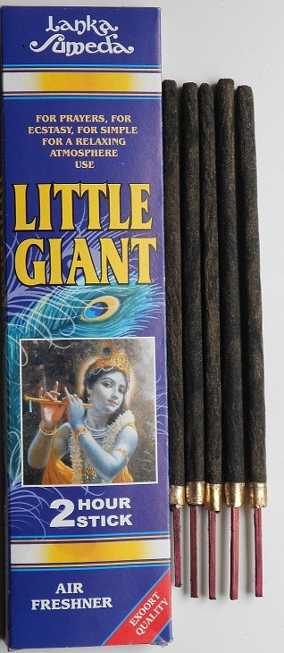

Lanka Sumeda
Smart Giant
This Giant 23 inches Thick Stick burn For 4 Hours. Many consumers as well as hotel trade they use this sticks for Spa Activates and outdoor ceremonies.
For Prayers, for Ecstasy, for Simple Charming, Sensory, Pleasures, for Relaxing Atmosphere.
Our Lowest Whole Sale Price$4.95
(Per packet)

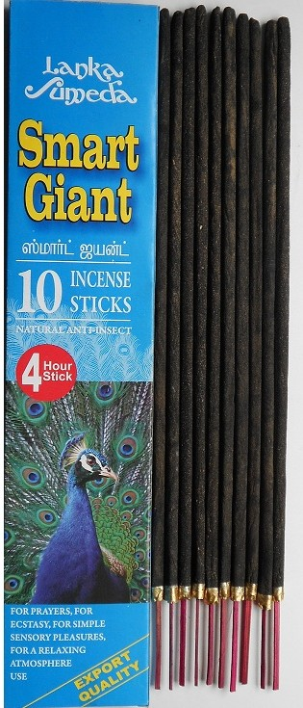

Ayurvedic 9”long 100% Natural Incense Sticks

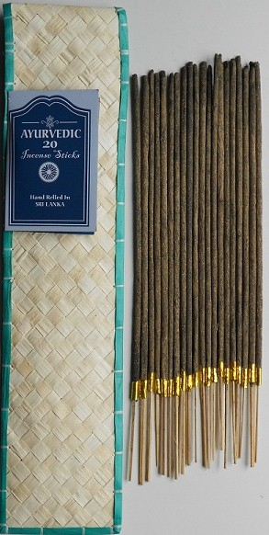
Ayurvedic, 9”long
100% Natural Ingredients
20 sticks
This 100% natural incense sticks does not give a strong fragrance but releases an aromatic smell
De-odorizing the atmosphere enabling, you to live with NATURE.
Dispelling any foul air.
This Natural sticks are free from any essential oil and has a medicinal effect too.
Pouches made of reed or palm leaves left to preserve and enhance the natural Fragrance.

This Item is very popular in Germany Italy and other European Countries.

Each Packet Whole Sale price as low as $0.99

Ingredients;, Aggar wood, Wishnukanthri, Many kinds of
Sambrani, Devadara, Sewandara, Suwanda cottan etc.
This Product is 100% lead free Non Toxic and hence is much safer and harmless.
To the lover of nature and to those who are allergic to anything synthetic, Lanka Sumeda has produced an incense stick with 100% natural ingredients.

Sumeda 50

Has followed an age old formula improved to suit the present day society. the fragrance is derived from a wide range of aromatic ingredients inter alia odoriferous resins, gums spices and indigenous herbs blended into a mixture.

This sticks are 8” long and burns for 30 minutes.

Sumeda 50 incense is capable of releasing a pervasive sweet fragrance, fit for a shrine room or an outdoor ceremony.

Sumeda 50 deodorizes living quarters and creates an appealing and relaxing environment for every day activity.
$.0.60cts

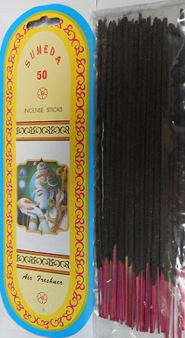

Sumeda 50

Royal Thai Sumeda Incense Sticks
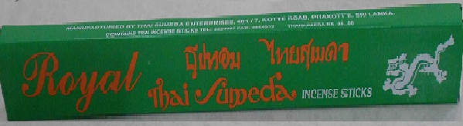

ROYAL THAI SUMEDA
This will give you very charm relaxing atmosphere.
This Packet also contains 9” long 10 thick sticks in a one Pack & come with 1 Dozen (12 Packets with 120 sticks) for $2.50

Thai Sumeda Incense Sticks
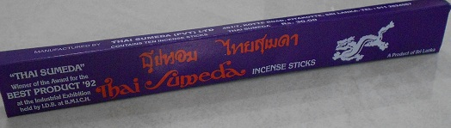

THAI SUMEDA
Gives Sensory Pleasures, most of the people like the smell and this brand is very popular with all religious people. This products has a big demands in all Supermarkets
It contains 9 “ long 10 thick sticks in a one pack & come with 1 dozen (12 packets with 120 sticks ) for $3.75

Thai Sumeda, Winner of the award for the BEST PRODUCT 92 at the Exhibition held by industrial Development Bored.

(램프오일)Thai Sumeda Thriloka Fragrance oil Lamps
Three Clay Lamps, Three Wicks and Fragranced Coconut Oil.
No Animal fat added

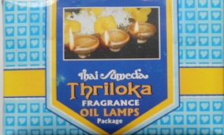
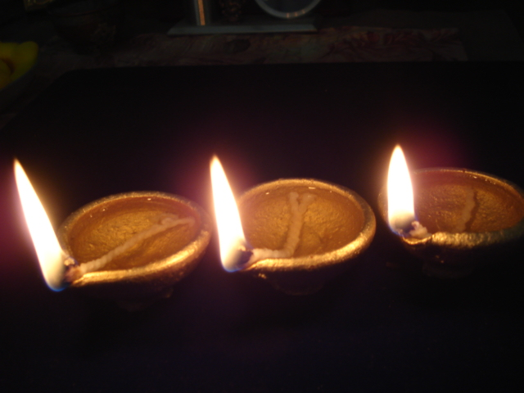
Our new product just came to the Market.
Introducing Price $.0.69c

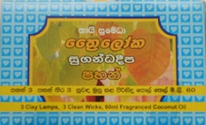

Thai Sumeda Incense Powder

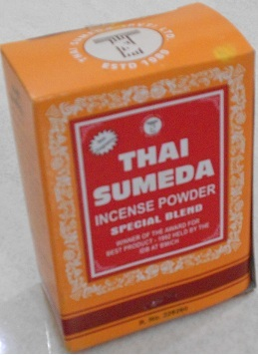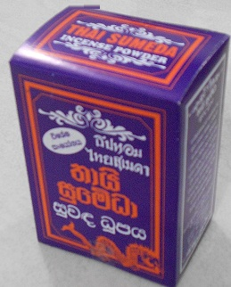
5o Grams 100 Grams
Incense powder 50 grams $0.35cts

Incense powder 100 grams $0.60cts

(핸드메이드 제품)
Hand Made & Hand Rolled in
Sri Lanka

  - These are local community based, Village scale Nature Friendly products. Your purchase means a real benefit to the many people in rural Sri Lanka !

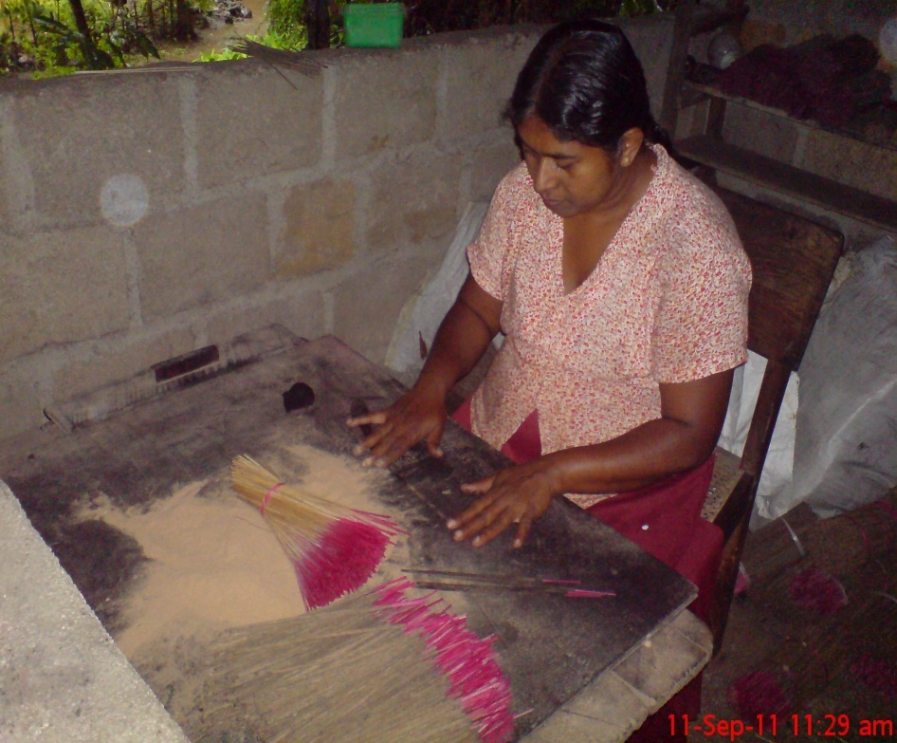

Working team and Products

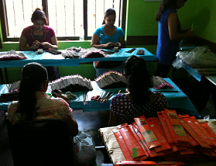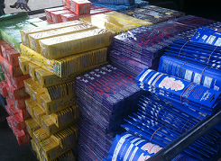
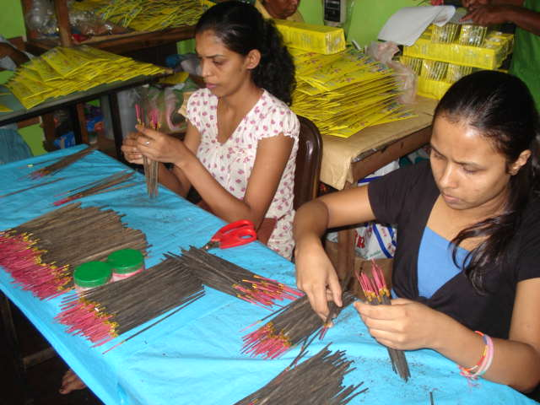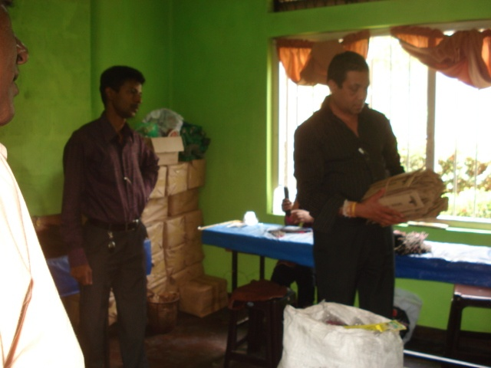
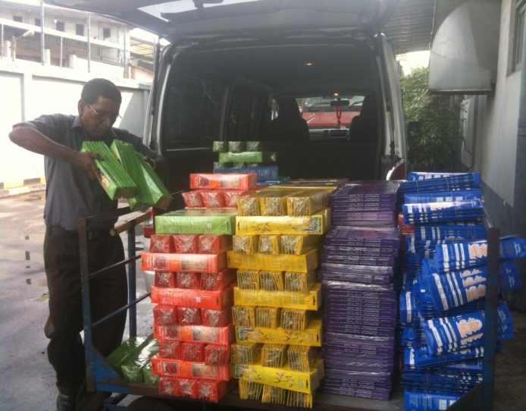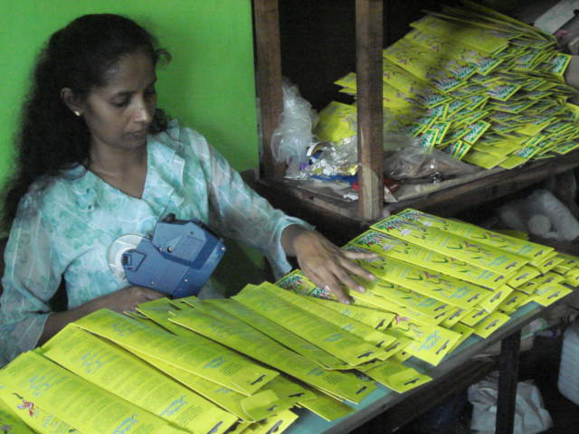

Quick Details
clear plastic bags with 20 sticks with Air tight inner Packages
진공포장으로 배송됩니다
Delivery(배송): |  | 7 working days

Minimum Order: 144 Dozens Variety
Payments: Strictly TT/ COD / Letter of Credit
All Prices FOB Colombo and all prices are final and valid for 6 months from the date below

Minimum order Sandalwood, Rose, Lily, Zinnias, Natural, should be 250 packets of each variety.
Minimum Order for Smart giant should be 50 Packets'
Minimum Orders for Royal & Thai Sumeda should be 200 Dozens each variety.

All Payments must be TT or Letter of Credit only, Goods will ship after bank conform your remittance to the Bank. Goods will be ready for shipping within two weeks after order is conformed.

May17th 2012
Regional Feature:  spa / Home / Office /  Hotel lobby / Hotel Rooms /  Out Door / In Door  Natural incense Sticks  Non Toxic Safe  Place of Origin: Sri Lanka |  | Brand Name: Lanka Sumeda

Thai Sumeda Brief Description

Brief Description

Manufacture of incense stick more than 23 years (23년 동안 제조)
Herbal incense sticks made from 100% natural formula (친환경, 자연적인 재료만을 사용)

Product Attributes
Related attributes of Natural incense sticks:
- Type: Stick Incense
- Material: Flower & Bud
- Use: religious, spa, therapeutic
- Regional Feature: Sri Lankan incense
- Place of Origin: Sri Lanka
- Brand Name: Lanka Sumeda / Thai Sumeda / Royal
- color: light Dark Brown
- Ingredients:100% natural formula - wood,
- size:24”,9” long and thick, 8”short and thin
- Health concerns: non toxic, free from carcinogen...
- burning time for long stick: I Houre,2 hrs and 4 hours
- burning time for short stick:40 minutes

Detailed Description Lanka Sumeda -

Following an age old recipe Lanka Sumeda has introduced to both the local and international markets, incense stick high Quality and super in standard. Prepared and blended with odoriferous resins, gums, spices and essential oils. Lanka Sumeda is capable of releasing a pervasive sweet fragrance in a shrine room, Spa, Hotel lobby, Hotel rooms or at an outdoor ceremony. It is an air - freshener to de - odourises living quarters and creates an appealing and relaxing environment for everyday activity. It also serves to expel the forces of evil and dispel any foul smell in the atmosphere .Lanka Sumeda is much longer and thicker than the average stick in the market, and burns slowly and gradually for longer period.

With these special characters Lanka Sumeda is fast becoming popular in the international market.

Lanka Sumeda hundred percent lead free and non -toxic and hence is much safer and harmless.

Lanka Sumeda Natural Ayurvedic Incense Sticks.

To the lover of nature and to those who are allergic to anything synthetic, Lanka Sumeda has produced an incense stick with 100% natural ingredients.

Sandal wood, agarwood, sewandara Suwanda cottan, wishnu kanthri, sambrani etc. etc.

Lanka Sumeda Natural Ayurvedic Incense Sticks does not carry much fragrance, But it release an aromatic light charming smell de - odorizing the atmosphere enabling you to live with Nature, dispelling any foul air. This is free from any essential oil and has a medicinal effect too.

It is something special with Lanka Sumeda that it could be stored safely along with other items in a Super Market or other groceries stores. It has been tested and experimented and found that our incense sticks does not pass on any scent or fragrance to other items stored side by side.

Detailed introduction to Natural incense sticks:
Herbal incense sticks made from 100% natural formula
Free from industrial chemicals, non toxic, free from carcinogens!
Made from ground wood powder, dried flower and herbal citronella!
Distinct spa aroma! 100% natural ingredients.
Generate herbal aroma and a feel for spa/therapeutic environs.
-------------------------------------------------------------------------------------------------

Company Profile:
Thai Sumeda Enterprises Established 1989 December 1st
Converted company as Privet Ltd on 2006 September 11th as Thai Sumeda (Pvt) Ltd.
Chairman & Managing Director Mr.Sumeda Elpitiya. (CEO)
Mobile Number; 0777788565
E.Mail : sumeda_us@yahoo.com

Director Sales And Exports ; Mr. Chandana Elpitiya
Mobile Number : 0777738452
E.Mail : elpitiyac@srilankan.com

Director Production: Mr. Sarth Pushpakumara
Mobile: 0777880018
e.Mail: thai.Sumeda@yahoo.com

Main Office & Packing Department:
Thai Sumeda (Pvt) Ltd.
401/7 Kotte Road,
Pita Kotte.
Sri Lanka
Telephone : 94 11 2 824087
Fax. : 94 11 2 854512
E.Mail: thai.sumeda@yahoo.com

Managers Packing Department . Mrs. W.K Anula
Number of Employees Packing Department.: 24
Factory; Thai Sumeda (pvt) Ltd
251/2 Gannoruwa,
Preadeniya ,
Sri Lanka
Factory Manager. Mr.W.A.N. Wikramarthna
Telephone: 94 815671246
94776325377
Number of Employees 68

Hoping for a successful business transaction and a long lasting business partnership.
Waiting for your best prompt act over this email
Best regards,

Sumeda Elpitiya
Chairman & Managing Director,
Thai Sumeda (Pvt) Ltd,
Manufacturers, Distributors & Exporters of
Incense Sticks, Incense Powder & all Incense Products
401/7. Kotte Road,
Pita Kotte,
Kotte.
Sri Lanka.
Tel 94 11 2 824087
Mobile: 94 777788565
Fax: 94112854512
E.Mail: thai.sumeda@yahoo.com
sumeda_us@yahoo.com



