

SOFIA,
REPUBLIC OF B U L G A R I A

- EN
- |
- BG

- Services
- Program
- Congress Center
- Press Center
- Partners
- About us
- Contacts
2013
2012
Events
Show past events (15)

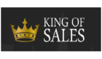

King of Sales
One of the world’s ten most sought after speakers to visit Bulgaria
28 March 2013

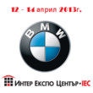

BMW and MINI EXPO
Certified second - hand vehicles
12 — 14 April 2013



Technomebel
Woodworking and furniture industry
23 — 27 April 2013

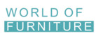

World of Furniture
Furniture, lighting, interior design
23 — 27 April 2013



Bulmedica / Buldental
Medical and dental industry
15 — 17 May 2013



Bulcontrola
Control and measuring devices, laboratory equipment
29 — 31 May 2013



Water Sofia
Water and water management
29 — 31 May 2013



South - Еast European Exhibition and Congress on Energy Efficiency and Renewable Energy
29 — 31 May 2013



Save the Planet – Exhibition & Conference on Waste Management & Recycling for South-East Europe
29 — 31 May 2013



Sofia Motor Show
Automotive industry
14 — 23 June 2013

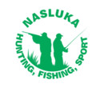

Nasluka - Hunting, Fishing, Sport
Intended for Hunters and Anglers
11 — 15 September 2013

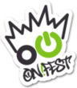

ON! Fest
Festival for urban culture
20 — 22 September 2013



COPI'S
Comunicatons, art, print, image, sign
08 — 10 October 2013

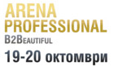

Arena of Beauty
Cosmetics, hairdressing, nail care, SPA & Wellness
19 — 20 October 2013

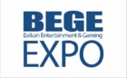

BEGE Expo
Balkan entertainment and gaming expo
22 — 23 October 2013



SIHRE
Hotel and restaurant equipment
06 — 09 November 2013



Interfood & Drink
Хранително - вкусова промишленост
06 — 09 November 2013

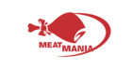

Meatmania
Meat industry
06 — 09 November 2013



The World of Milk
Dairy industry
06 — 09 November 2013



Bulpek
Bakery and Confectionery industry
06 — 09 November 2013

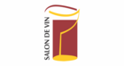

Salon de Vin
Wines and Spirits
06 — 09 November 2013

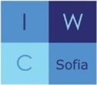

IWC Annual Charity Bazaar
19th Christmas Charity Bazaar
01 December 2013




Developed by Devture and Gaming Entertainment.
Bulgarreklama © 2012

