Short about VCS:
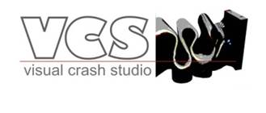
The VCS is a software for pre design of structure.
Macro elements methodology of VCS is very fast. Thanks to that a user can make a number of concepts of a structure and test it in minutes which stays in opposition to software based on finite elements where user needs hours or days for one concept.
VCS software has no direct software competitors.
In VCS program user defines a concept for complex crashworthy structures, and than designs details in another softwares.
VCS and software based on FE Methodology complement each other providing an overall design environment by combining fast pre design assessments with later detailed calculations.
Industrial Visual Crash Studio and Crash Cad users (in historical order):
VOLVO, BMW, FIAT, AUDI, PSA, ROVER, LOTUS, HONDA, HONDA AMERICAS, MAZDA, MITSUBISHI, TOYOTA, DAIHATSU, HINO, NISSAN, ISUZU, CORUS (BRITISH STEEL), ALCOA, SUMITOMO, ALCAN, DLR, SIEMENS, DUARTE, SAIC UK, VOESTALPINE, GELLY, LKR RAMSHOFEN, HYUNDAI GERMANY, H-ONE
What is VCS
Visual Crash Studio (VCS) is an all-in-one environment for early design, virtual testing and optimization of complex crashworthy structures.
Visual Crash Studio (VCS) has been created at Impact Design, Europe by Dr. Wlodek Abramowicz. Based on the concept of Super Folding & Super Beam Elements, and original Object Oriented Finite Element (OOFE) formulation, VCS is an unique software for fast crash analysis of thin-walled and solid space frames.
Visual Crash Studio is a successor of the renowned CAE program Crash Cad (1990 – 2005) developed at Impact Design in early 90-ties of the last century. Crash Cad was capable of analyzing and design for crash of a single thin walled prismatic member and was finally replaced by Visual Crash Studio around 2005.
Both programs are based on the macro element methodology devised by Alexander in 1960. The complete theory of the macro element method was worked out (among others) by T. Wierzbicki and W. Abramowicz and N. Jones in late eighties of the last century. The computerized version of the current macro element version is based on works of Wlodek Abramowicz.
Visual Crash Studio is an all-in-one environment for early design, virtual testing and optimization of complex crashworthy structures. The design process starts at the level of cross section and material selection. Next individual beams, subassemblies and complete structures are tested in the virtual environment. Final optimization is done in external software via batch mode option of VCS.
The VCS is probably the most advanced software for design of energy absorbing sections and simulation of crushing response of arbitrary space frames. VCS is widely used in the automotive industry worldwide.
The benefits of using VCS
VCS is especially useful at early stages of the design process when fast assessment of various structural configurations substantially speeds up product development process. It is an all-in-one environment for early design, which means that the user may easily test, modify and optimize the cross sections as well as complex structures. Compared to a FE model the VCS Macro element model gives similar results in substantially shorter period of time (seconds). The constantly improving modeling tools for 3D view enable the user to easily modify the tested construction.
VCS effectively combines complex macro element solutions at the level of individual elements with object oriented implementation of the global equilibrium solvers. Two major areas of application of the VCS are design and calculation of thin walled members for optimal crash performance and flexible crash simulation of structural sub-assemblies and complete space frame structures. It should be noted that early predecessor of VCS the CAE program Crash Cad was capable of calculation and design at the cross-section level only. Now the enhanced functionality of this program is included as one of several dedicated design modules of VCS.
The design of a structural member at the cross sectional level is especially important at the pre design and early design stages when the proper shape and optimal dimensions of a member are sought and the design concept undergoes frequent modifications. The macro elopement approach is especially attractive at this level as the calculation routines require as input only overall dimensions of the cross – section, and tensile characteristic of the material while the calculation process takes only few seconds on a standard PC. Consequently, designer can examine a wide range of cross sectional topologies and run several parametric studies within only few hours of work.
The design and flexible crash simulation of structural sub-assemblies and complete space frame structures made in VCS gives results of exceptionally good agreement (with respect to both crushing characteristics and deformation shape) compared to the FE models simulations. The time needed for the VCS simulation is however substantially shorter. For example the macro element model (rear frame) consisted of 45 nodes and 56 macro elements required 30 sec. CPU on a 2GHz Windows PC.
The macro element approach is extensively used in the crashworthiness community for fast analysis and preliminary design of energy absorbing structures. Recent developments in macro element methodology confirm robustness and accuracy of macro element models in crashworthiness simulations.

Below you can find some examples of comparison and results received in VCS, an FE CAE software and experimental data.

“Design of energy absorbing structures is achieved in several steps, usually in a highly iterative design/calculation process. Objectives of each design step are achieved by usage of dedicated computational tools typically different for each step. The selection of an appropriate tool depends on the complexity of the problem…” [1] Application of advanced computer programs which is equal with creating simulation models in specified environment gives only a prediction of construction behavior exposed (in case of crash events) to dynamic load. The practice shows that wide range of simulation tools may give different results for the problem defined with identical boundary conditions. It only confirms the fact that the great art is to choose appropriate methodology for problem solution and adequate predictive technique which reflects reality in virtual world with the most suitable way. The instance described below shows a comparison between the real world experiment and simulations performed using two simulation methodologies.
Figure 1 shows the VCS model of the complete rail assembly. Two rails are discretized into total of 10 SBE. Experiments were conducted with low, constant velocity of 10 [mm/min]. Standard VCS procedure, described in the Modeling Guide, was applied in order to determine the equivalent crush velocity of 0.1 [m/s] and corresponding CFC 60 filter. It is worth nothing that in this particular case there is virtually no difference between original and filtered characteristics. This is due to the relatively thick walls of the tube (R/t = 19). The collapse of the structure is well within the plastic range and is not accompanied by large elastic vibrations.

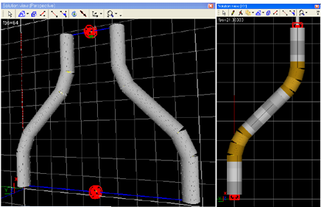

Figure 1 The VCS model of the complete S rail assembly.

The results of preliminary VCS simulation (red line) are shown in Figure 2 together with FE predictions. The FE result (22.5 [kN]) falls well below the experimentally measured peak force of 30.5 [kN]. The VCS result (27 [kN]) is also 12% below the experiment.

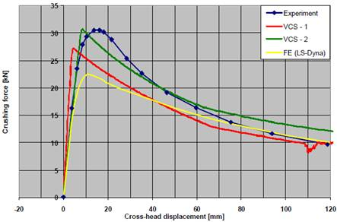
Figure 2 Comparison of VCS predictions with experimental data and FE simulation.

A possible explanation of this discrepancy is a likely presence of residual plastic strains in the bend sections of the rail. The tensile properties of the rail material were tested on standard specimens cut off from straight section of the tube and then machined flat. The material appears to harden appreciably, especially for small strains, Figure 3. It is possible that residual plastic strains in the bend segments increase the yield stress of the material well above the measured 115 [MPa]. In order to account for this phenomenon a new model of material is defined in VCS by “cutting off” the initial 2% of the original tensile curve, as illustrated on the second graph in Figure 3. This operation increases the initial flow stress by 8% to the level of 125 [MPa]. Since the information on the manufacturing technique of the rails is not available the selected value of 2% is just an intuitive assumption which should demonstrate sensitivity of the solution to the initial yield stress and strain hardening of the material early in the plastic range.
In the next VCS model one leg of the rail is discretized into 17 SBE in order to introduce hardened material in the bend region. The goldenrod elements in Figure 21 correspond to tougher bend segments (note that SBE adjacent to bend region have deformable cells with different material properties at both ends). An additional User Defined Beam Element in VCS model represents the elastic stiffness of the testing equipment, Figure 4.

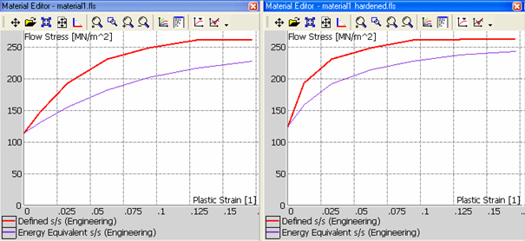
Figure 3 Original and modified tensile characteristic of aluminium. The removed initial section of the
tensile curve simulates state of material following the manufacturing process

Results of VCS simulations are shown in Figure 2 (green line) and in Figure 4. It is evident from the graphs in Figure 2 that the peak force is very sensitive to the strain hardening of material in bends of the rail. However, the excellent correlation of the experimental and measured peak force should be confirmed by additional material tests. Final configurations in Figure 4 show excellent correlation. Note the position of collapsed elements (red) that matches exactly collapsed regions of an actual specimen.

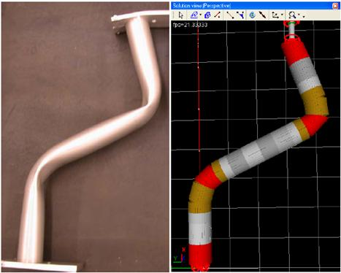

Figure 4 Deformed configurations after quasi static experiment. Left experiment right VCS simulation
(collapsed sections are marked in red).

[1] Wlodek Abramowicz - The macro element method in crashworthiness calculations - the state-of-the-art and the future. Impact Design Europe, 2007 Project

VCS is used in R&D departments, and the outcome of the work performed on VCS is often to some point confidential. It is why it’s not so easy to provide success stories of the usage of VCS.
But the latest EU project ‘SmartBatt’ is a good example of the usage of VCS: http://www.impactdesign.pl/images/structural_analistic.pdf

The all information about news VCS 2.1, VC S2.2 and VCS2.4 you can find on http://www.impactdesign.pl/news.html
Impact Design's policy is that each user can request and receive all new versions of VCS during the one year licensing period without additional costs.

All VCS manuals and presentations can be found on our web page www.impactdesign.pl
The newest part of the manual – 3D Simulations – should be available.
In those materials you can find information about VCS modeling, Cross Section Editor, Material edition etc.

Our support team is also available in case of any questions regarding the usage of VCS tools (support@impactdesign.pl).
Please contact our support team by mail. They will respond as soon as possible.

Please find VCS demo version on: http://impactdesign.pl/demo/

login: DEMO
password: IDE4321VCSDEMO

If you have any questions or suggestions regarding Visual Crash Studio please feel welcome to contact me directly.

