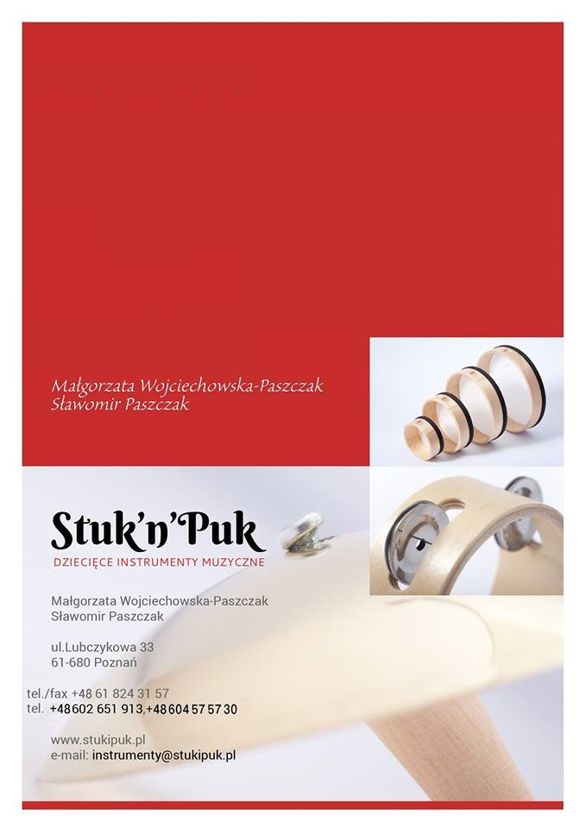

Dear Dirs,
We are producers of percosion Orff instruments for children. That fits they needs and possibility at the beginning of their musical education.

We offer hight quality instruments. We use selected wood with perfect sound and special metals for triangels and jingles. Drums have very strong skin. Xylophones and Metalphones are electronicly tested.

We hope you will find our offer attractive.
Best reqarts

