A VISIT TO AFOREX Co., Ltd.

- Visitors: Mr. Hae Jung Oh (Advisor to the Department of Planning and Investment), Mr. Luong Anh Tuan (Co-worker), Interpreter.
- Date of visit: January 21, 2014

1. General information of Aforex Co.,Ltd.
- Established in March, 2010
- Director: Pham Thi Giang
- Addess: Km 4- Hung Vuong St, Lang Son, Viet Nam
- Factory: Chi Lang District, Lang Son Province , Viet Nam
Phone: +84 988.888.036 Fax: (025) 3 882 222
- E- mail: staraniseedvietnam@gmail.com

2. Products
a. Star Anise
- Appearance: well-dried, clean, no mould and no fungus
- Natural reddish colour
- Flavour: featured aroma
- No stem: admixture (1 %)
- Moisture: 13.5%
- Flower size: 2 cm up
b. Star anise powder
- Appearance: Orange brown powder
- Texture: coarse
- Odour: characteristic
- Flavour: typical
c. Star anise oil
- Melting point: 150º c
- Boiling point: 2320ºc
- Trans- Anethol: 80%/ min
- Stability: stable under normal condition
d. Cinnamon oil (mostly for trade exhibitions)
- Appearance: golden yellow
- Odour: characteristic
- Taste: very hot aromatic

3. Production capacity/ export / employment
a. Production ( 2013)
- 20,000 tons ( account for 71% of total production in Vietnam)
- Cultivation area: 32,000 ha
- Turn over: VND 40 Bil

b. Production method
- Aforex Company purchases anise flowers from local farmers who collect those raw materials in the forest and farms
- Dry in sunshine after water cleaning
c. Employment: 25 regular workers (Harvest season: more than 100)
d. Export.
- India ( 80 %), United Kingdom, China
- India re-exports star anise to Middle Eastern countries
- Export price: 2.5 USD/ Kg
- Total export amount : 9,650 tons
- Payment: irrevocable L/C at sight

4. Effects of products
a. Herbal Medicine
- Flu and footbath soaking
- Stomach cramp and mouthwash
- Insect bite
- Killing bacteria
b. Food procession
- Marinating beef, dog and duck
- Preserve foods
c. Cosmetics
- Body massage
- Perfume
- Shampoo

5. Corpoate managements and requests to the Government
a. Capital mobilization
- The company mobilises capital by borrowing from commercial bank at an interest rate of 6 %/ year
- The company is required to deposit mortage of which value is as much as twice of loan from bank
- The company hopes to have joint ventures for capital inducement
b. Entry to the foreign markets
- The company exports only star anise and hopes to export star anise oil either ( The company has never sold oil to foreign markets)
- The company hopes to participate trade fairs/ exhibitions in foreign countries
c. Geographical Indication Registration
- The company has been granted to use Geographical Indication from Provincial People’s Committee and the Department of Science and Technology, Lang Son Province for 5 years since 2010 and hopes of extension of GI usage

6. Advisor’s judgment, measures to be taken and recommendations

a.Judgment
- Aforex Co. contributes to local economy development especially in employment and export (It’s total amount of export was 25mil. US$ in 2013)
- Aforex Co. is the biggest star anise exporter in Vietnam
- Collecting, drying star anise are done by conventional method
- For the high quality of star anise oil sophisticated producing technology development is essential to the company

b. Measures to be taken
a. Financial assistance
- More information should be provided for enterprises to get more government assistantces ( vice - versa, enterprises have to make more efforts to learn more gov’t informations themselves)
- Banks should be advised to lower the interest rate and to increase the amount of loans
b. Foreign market penetrations
- The Department of Industry and Trade is advised to provide enterprises with more foreign market information through Foreign Trade Offices abroad ( Especially Trade Offices in Middle Eastern countries are advised to collect information to help Aforex Co directly export to those regions)
c. Patent/ Trademarks/ Geographical Indication
- The Department of Science and Technology is advised to extend the usage of GI and to originate more GI’s for the provincial characteristic products
- Measures to be taken to urge the company to apply for patents and trade marks if possible
d. Search for possibilities of Korean investors
- Mr. Oh ( Advisor to Department of Planning and Investment) is going to collect more information of the company and their products to send to KOTRA ( Korean Trade and Investment Promotion Agency) Hanoi Office
- To ask the Office to look into the information and search for possible Korean investors and importers

c. Recommendation to DPI
- DPI is advised to diversify dialogue channels with enterprises in the province to listen their voices
- DPI is strongly recommended to send DPI officials to enterprise sites throughout the year
- At least 1/3 of officials is requested to go, listen and talk with enterprises at all times
- DPI should seek Inter-Departmental cooperation mechanisms to address issues mentioned above

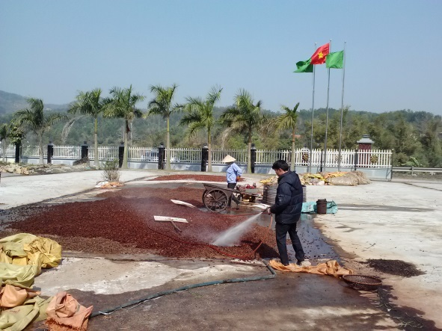
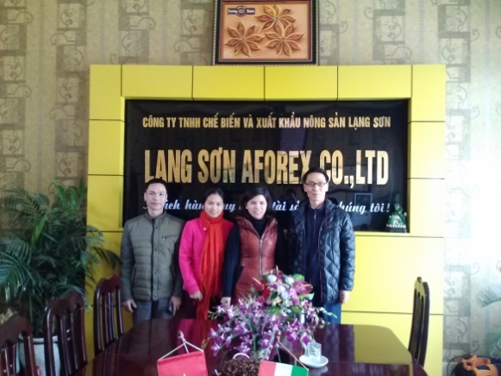

visit to the company workers washing and drying anise

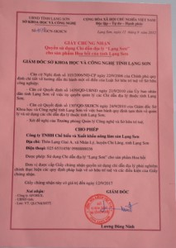
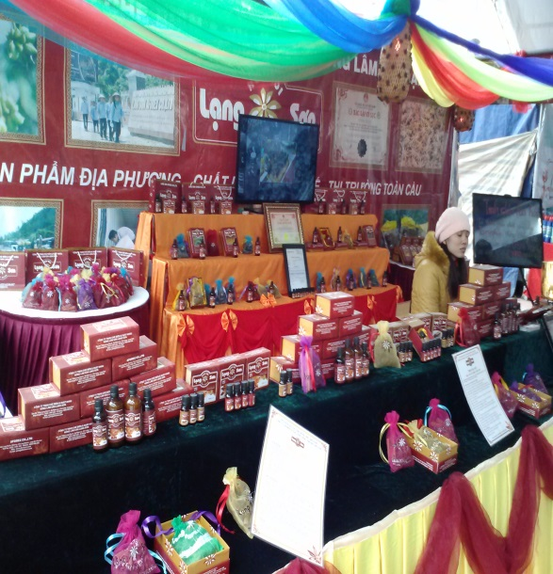
Geographical Indication

Products in the market festival

