INVITATION LETTER

To whom it may concern,

On behalf of the Embassy of the Socialist Republic of Viet Nam in Seoul, I am pleased to invite you to participate in the conference “Trade promotion between Vietnamese and Korean enterprises” to be held at the Conference room (South) 317BC, Coex from 14:00 to 17:00 on 05^{h} June, 2018 .

The conference is co-organized by the Yen Bai provincial Department of Industry and Trade and Trade Office - Embassy of Viet Nam in Seoul. The purpose of the Conference is to strengthen closed relationship between the two nation’s enterprises, assisting the enterprises to have more opportunities to explore business and culture environment as well as to determine specifically market demand and production supply for each enterprise.

Enclosed please find details of program schedule, list of Vietnamese enterprises and registration form.

Please RSVP no later than 01st June, 2018, by filling in the attached form and emailing:

Mr. Bui Viet Truong (truongbv@moit.gov.vn; HP: 010 7255 8686).

We look forward to seeing you at this conference.

Yours sincerely,
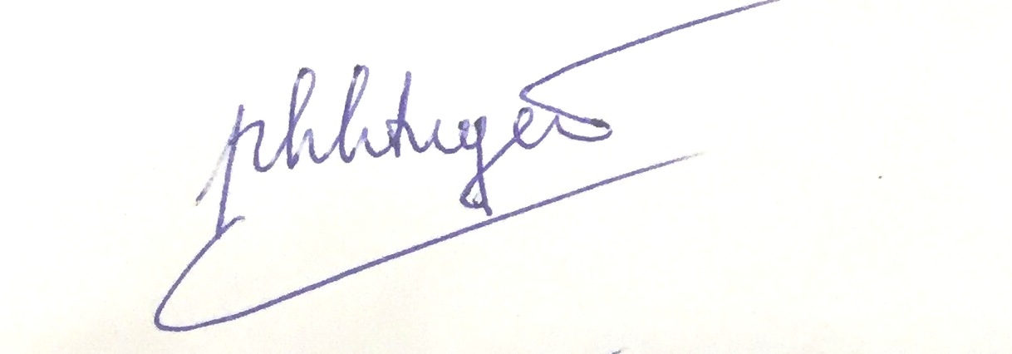

Mr. Pham Khac Tuyen
First Secretary
Head of Trade Office, Embassy of Viet Nam in Korea

PROGRAM SCHEDULE

TIME | CONTENT | Speaker
14:00 – 14:30 | Registration
14:30 – 14:45 | Welcome speech | Vietnam Embassy in Korea
14:45 – 15:00 | - Introduction of officials and enterprises of Yen Bai province - Vietnam.  - Presentation clip about potentials and strengths of Yen Bai - VietNam | Mr. Pham Trung Lan - Deputy Director of Department of Industry and Trade of Yen Bai Province
15:00 – 17:00 | B2B Meeting  (Divided into 03 groups of products) | 03 product groups:  - Agricultural products  - Timber for plantation  - Mineral and construction

LIST OF VIETNAMESE ENTERPRISES

NO | Company's name | Business sector
I | AGRICULTURE PRODUCTS
1 | Yen Bai Agro-Forestry Products and Foods JSC | Producing, processing and trading in agro-forestry products. Products of the company: Paper base, exporting paper, cassava starch, cinnamon essential oil.
2 | Shan Van Chan Tea Cooperative - Suoi Bu Commune | Producing and processing green tea, black tea
3 | Dong Yen Private Enterprise | Processing Cinnamon Custard, Cinnamon Essential Oil; planting fruit trees; Forest tree planting (cinnamon); Raising cattle (cow)
4 | Hoang Que Van Yen Co., Ltd | Producing and trading in cinnamon, anise, medicinal plants, cinnamon essential oils and essential oils
II | TIMBER, WOOD PRODUCTS
1 | Yen Thanh JSC | Producing and trading in agro-forestry products (main products: plywood and bamboo shoots)
2 | Dang Khoa Private Enterprise | Wood processing plantation, production of joinery
3 | Northern Paper One Member Co., Ltd | Manufacturing printing paper powder, paper and cover
III | MINERAL AND CONSTRUCTION
1 | Hoang Lien Son Technical Ceramics JSC | Manufacturing and trading in porcelain insulators
2 | No 1 Development One Member Co., Ltd | Exploiting, processing and exporting white CaCo3; Exploiting, processing and exporting iron ore
3 | Van Phuc Yen Bai Import Export JSC | Production of CaCo3 stone powder; Artificial white gravel
4 | Dai Luc Co., Ltd | Wholesaling materials and equipment installed in the construction works; Construction of houses and civil engineering
5 | Nam Phat Co., Ltd | Construction of houses of all kinds; Constructing other civil engineering works; Installation of electrical systems; Mining iron ore
6 | Hong Nam JSC | Manufacture of electric poles, wooden chopsticks
7 | Yen Bai Transport and Construction JSC | Road and bridge construction, ground leveling, pouring concrete components, asphalt mat

REGISTRATION FORM

Name
Company/Organization
Address
Business field
Tel
Email

I would like to attend the conference and meet with the following companies
(Please indicate Vietnamese companies that you wish to have 1:1 meeting)

1.
2.
3.
4.
5.

Contact person:
Mr. Bui Viet Truong (truongbv@moit.gov.vn; HP: 010-7255-8686; Fax: 02-364-3664)

