Established in 2001, Vitalcan Argentina started up driven by entrepreneurial passion and a clear goal: to improve the lives of pets through the development, production, marketing and distribution of the best integrated nutritional solutions.
We are the only company that researches and produces in Argentina; and our products, supported by vet nutrition specialists, are mostly commercialized in Veterinary Clinics and Pet Shops. We are known by permanently innovating, aiming to offer a wide portfolio of products for the different segments of the local and international market, bringing the quality of Argentine raw materials to the world.
Due to the consolidation and leadership achieved in the local market, Vitalcan has gone through a significant growth process supported by the development of new markets at international level. Currently, Vitalcan products nourish the vitality of cats and dogs in Chile (new subsidiary), Bolivia, Paraguay, Uruguay, Peru, Ecuador, Colombia, Costa Rica, Panama, Indonesia, China, among other countries around the world.
Our goal is to continue expanding our horizons. In the framework of the International Development Plan of Vitalcan, entering your country’s market becomes our priority. Consequently, we are in search of an Importer / Distributor for our products, both for the veterinarians and pet shops. We have 7 different brands for all spending powers: 4 brands for the Specialized Market (Therapy, Nutrique, Balanced, Complete) and 3 brands for the Mass Market (Premium, Hop and Belcan). We are in search for 2 different distributors: 1 for the Specialized Market and 1 for the Mass Market.
Here are the links to our websites so you can know more about us and our products:
NUTRIQUE
Our newest launch: a holistic approach to nutrition, based on turkey protein and free of soy, wheat and corn.

THERAPY
Therapeutic line.

BALANCED for dogs
Super-premium line for dogs.
BALANCED for cats
Super-premium line for cats.
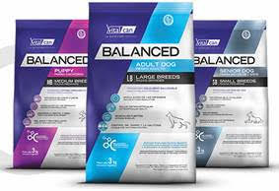
COMPLETE for dogs
Standard line for dogs.
COMPLETE for cats
Standard line for cats.
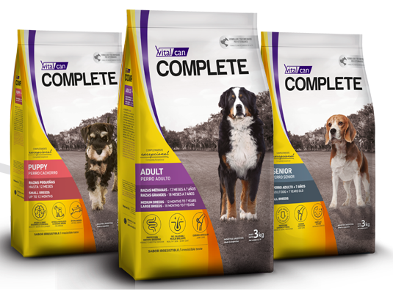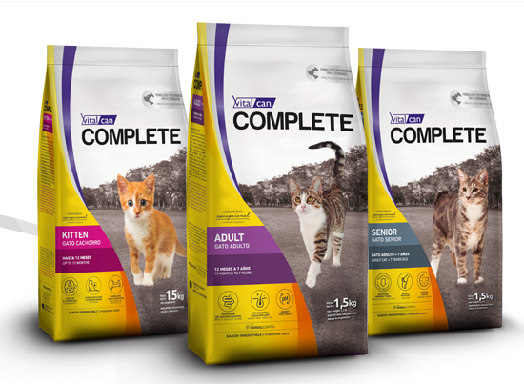
PREMIUM
Premium line for mass channels.

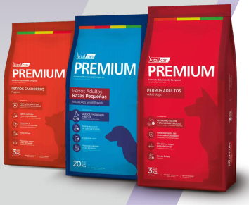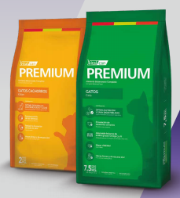

HOP!
Standard line for mass channels.

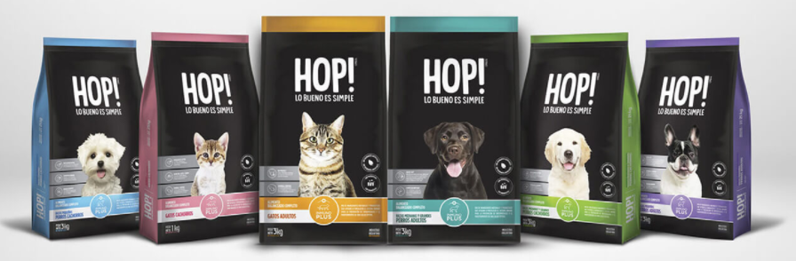

BELCAN
Standard line for mass channels.

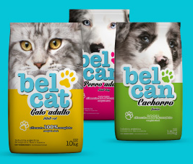
Please reach us by replying to this email, and we’ll get back in touch as soon as possible.
We look forward to hearing from you.
Best Regards

