Introduction of China International Furniture Fair (Guangzhou)
Established in 1998, China International Furniture Fair (known as "CIFF") has been successfully held for 52 sessions. Since September2015, it takes place twice yearly in both Guangzhou in March and Shanghai in September, two of the most vibrant commercial cities in China. Over the years CIFF has built itself as the world's largest home furnishing fair with the entire industry chain, playing an important role in global furnishing industry.

Positioned by "Design Trend, Global Trade and Full Supply Chain", CIFF Guangzhou is held annually in 18-21&28-31 March in Pazhou,Guangzhou. With an exhibition area of 830,000 square meters, CIFF Guangzhou hosts over 4,000 brands from China and abroad, comprising home furniture, home decor & home textiles, outdoor & leisure, office furniture, commercial furniture, hotel furniture, and furniture machinery & raw materials. The event draws more than 380,000 professional visitors from more than 200 countries and regions.

CIFF Guangzhou is dedicated to industry development and global trade, making it the foremost exhibition for "Design Trend, Intelligent Manufacturing, Trade Promotion, and Quality Consumption."

Dates & Opening Hours
Mar18-21, 2024: (Home Furniture/Homedecor & Hometextile/Outdoor Leisure)
Mar28-31, 2024: (Office and Commercial Space CIFM / interzum guangzhou)
Venue
China Import &Export Fair Pazhou Complex / PWTC Expo
Hosts
China National Furniture Association, China Foreign Trade Centre Group Ltd., Guangdong Furniture Association, Hong Kong Furniture & Decoration Trade Association
Organizer
China Foreign Trade Guangzhou Exhibition Co.， Ltd.
Supporters
Hong Kong Trade Development Council, Taiwan Furniture Manufacturers' Association
Co-organizers
Guangzhou Furniture Association, Beijing Furniture Trade Association, Shunde Furniture Association, Zhongshan Furniture Association, Dongguan Furniture Association, Yuhuan Furniture Industry Association, Guangzhou 020F Furniture Club

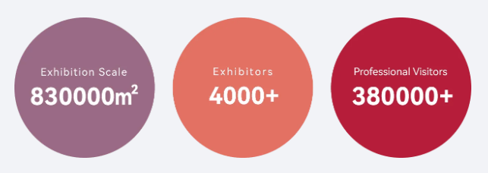

Reasons to Visit CIFF (Guangzhou)
- Comprehensive Products
CIFF covers the entire industry chain including home furniture, homedecor & hometextiles, outdoor & leisure, office furniture, commercial furniture, hotel furniture and furniture machinery & raw materials.
Diversified Brands
2. CIFF(Guangzhou) gathers over 4000 domestic and overseas furniture brands. Leading enterprizes bring shining new products while newly emerging brands showcase the charm of vitality. Top brands of China and broad present the best under the same roof, together creating the best commerical platform for prodcut launch, domestic sales and export trade.
3. Exciting Activites
CIFF holds a series of exciting design activities, forums and launch events to help exhibitors and visitors grasp the latest trends of the home furniture industry, offering a feast of fashion and trend for the entire industry.
4. Friendly Services
CIFF keeps improving the onsite service. With convenient entry, humanized visiting route, hall facilities, VIP reception, catering, hotel and transportation services, CIFF offers friendly experience to all participants.


