Benefits for International Visitors
InterBiz Club (International Business Club) is a service ecosystem specifically for international visitors from over 200 countries and regions. Drawing upon CIFF’s 26-year global resources, it integrates multiple channels to help build a new ecosystem for home furnishing foreign trade. InterBiz Club employs a two-fold approach, consisting of 8-day offline exhibitions along with year-round online engagement, to expand global market channels. During the exhibitions, InterBiz Club facilitates multi-route pavilion interactions, trade negotiation meetings, VIP treatment and attentive services to empower global visitors to explore boundless business opportunities in China. Throughout the year, InterBiz Club takes a series of measures, both online and offline, to extensively expand international trade orders, including the "Greater Bay Area Factory" Tour, a virtual exhibition hall, online matchmaking meetings, an all-media matrix encompassing the official website, overseas social media, EDM, and more. This effort aims to facilitate precise connections between suppliers and buyers, thereby fostering trade transactions.

- An Eight-Day Offline Fair
- Comprehensive Product Offering
Full coverage of industry chain: home furniture, home décor & home textiles, outdoor & leisure, office furniture, commercial furniture, hotel furniture, furniture machinery & raw materials.
- Diverse Brands
4000 local and international furniture and related brands, latest, finest, best all under one roof, tapping the best commercial platform for product introduction, domestic sales, and export trade.
- Wide Array of Activities
Design & trend showcases, forums, launch events
- User-Friendly Services
Expedited fair access, comprehensive hall amenities, VIP welcome program, assortment of food & beverage options, choices of accommodation, complimentary transportation services

- 365 Days Online Business-Matching FREE
- Social Media Interaction & with regular update
facebook, instagram, twitter, linkedin (over 1,2million views)
- ZOOM business-matching
Assisting retailers, wholesalers, e-commerce firms, import and export enterprises to match with reputable suppliers
- Request for Quotation (RFQ)
CIFF has launched a brand-new column of RFQ at https://www.ciff-gz.com/exhibitors/rfq, which supports the supply and purchase for 365 days throughout the year.

- VVIP Reception Program FREE
- To qualify for the VVIP Card:
Annual purchase volume exceeding USD 10 million; or professional buyers from the global TOP 500 companies or local TOP 100 enterprises; or big buyers with more than 5 multinational chain stores or a showroom with more than 2000SQM.
- VVIP Privileges:
Long term effective for CIFF in different cities without repeated registration; express entry at all CIFF events; CIFF VIP Lounge service with one companion; exceptional customer service and free trade matching service; VIP reception at booths of exhibitors; one free lunch voucher, show brochure, carrier-bag, and show guide; free participation in different trade activities and special exhibitions presented during CIFF; shuttle bus ride between assigned hotels and fairground

- Gift Package (For International Visitors who takes part in the Campaigns of CIFF’s social media)
Air-tickets, hotel accommodation, land transportation, and food coupons for winners from CIFF’s international social media’s events.
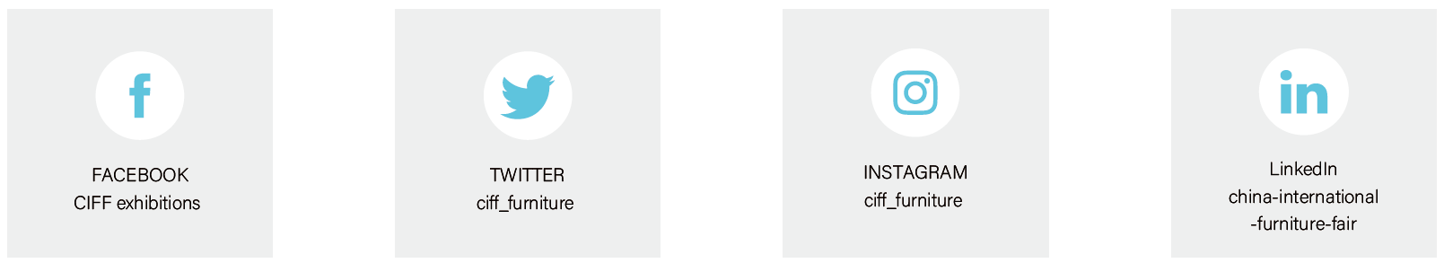

- CIFF Furniture Factory Tour Program
Complimentary service to international buyers to connect with local suppliers, including:
- FREE tour guide services and translation with optional choice of routes, professional translator and dedicated guide provided
- FREE accommodation during the tour
- FREE meals of authentic local cuisines during the tour
- FREE transportation during the tour

