PROPOSAL #1
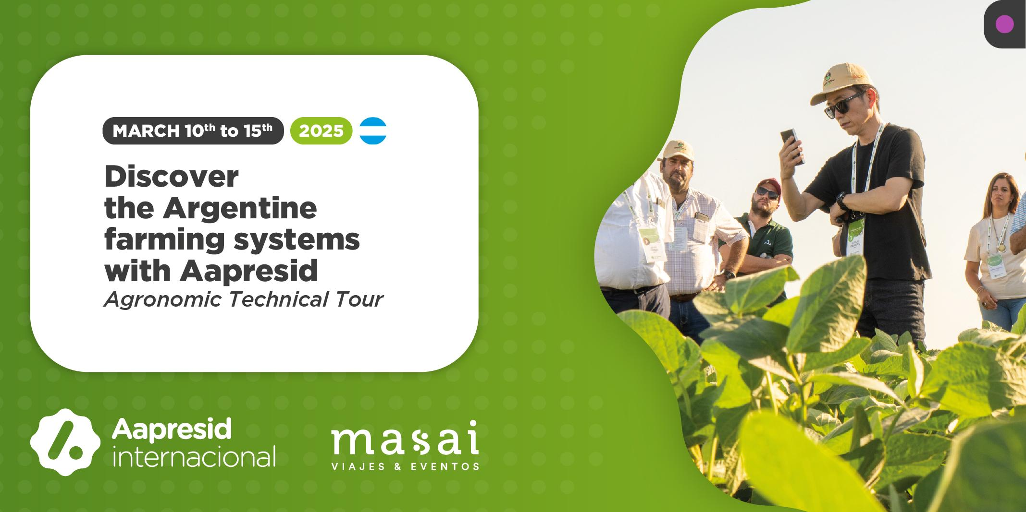
“Did you know that Argentina, in addition to being football world champions, or the place where Tango emerged, is also the #1 country in regenerative agriculture?

Yes, you read that right, our farmers promote the sustainable production of food, fibers and energy, soil conservation and regeneration, and much more! Aapresid invites you to get to know our country through our sustainable perspective, more information below 👇

#agriculture #sustainable #conservation”

PROPOSAL #2
Would you like to get to know Argentina from a different perspective? Aapresid invites you to discover our country’s agriculture from a sustainable point of view, a type of agriculture that regenerates the soils and cares for the environment. Contact us for more information. Join us!

