NEWSLETTER PROPOSAL
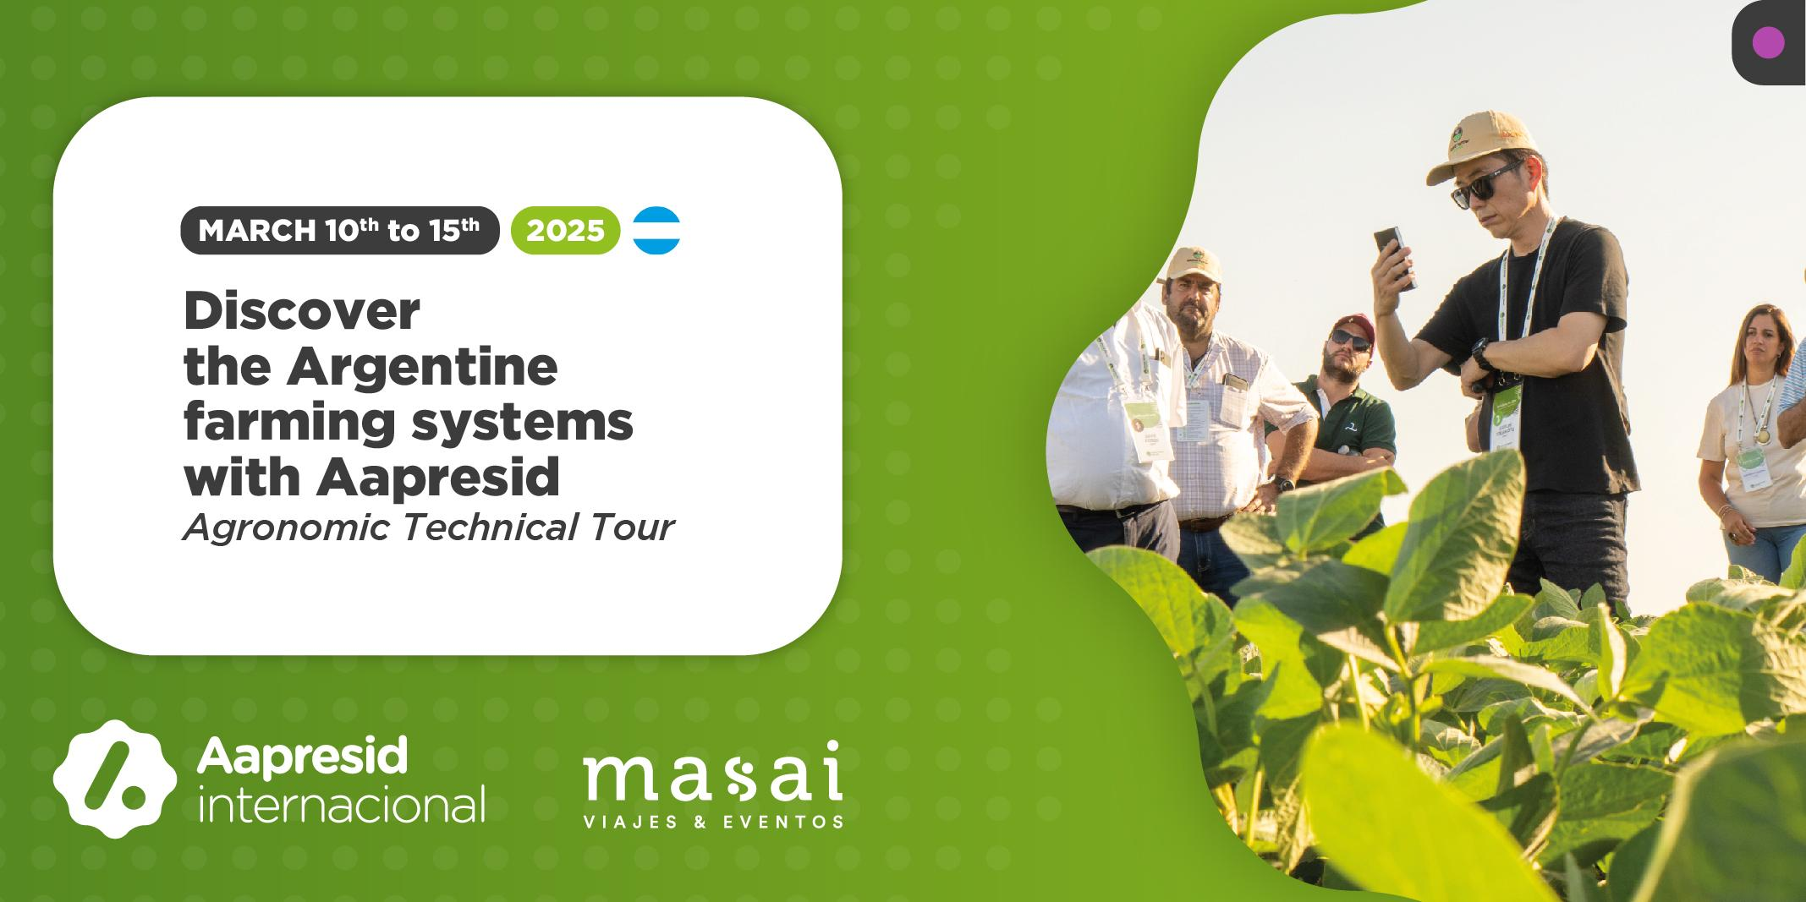
TITLE: Discover the Argentine farming systems with Aapresid
SUBTITLE: Agronomic Technical Tour from March 10th to 15th 2025

Join this unique experience to discover and learn about the Argentinean agricultural systems.

At Aapresid we strongly believe that protecting the soil is paramount for our present and our future, and in this sense we have organized a technical tour to explore and get to know our advanced production models, recognized for soil care, sustainability and innovation in networks.

The trip, which will take place during a week, includes field visits in the main productive regions, encounters with leading agribusiness companies and institutions, as well as interesting technical exchanges with farmers and local experts, who will be accompanying you throughout the tour.

You will also attend the largest open-air agroindustrial exhibition in the region, Expoagro, where you could learn about the latest trends in agricultural machinery, inputs, services and livestock in our country and Latin America.

The proposal includes the logistical and organisational aspects detailed in the brochure, which you can access by clicking here.

Pack your bags! And don't miss the opportunity to discover, connect and learn on this unforgettable journey!

